**Name : Shahzadi Begum Shaikh Rafique**

**Assignment : C Sharp 1st Assignment**

1. Write a Simple console Application Calculator with the help of Visual Studio .NET IDE which will perform following operations on two numbers:
2. Addition.
   1. Subtraction.
   2. Multiplication.
   3. Division

Accept input from user and display results on console. Make use of loops, switch case wherever required.

**Output**

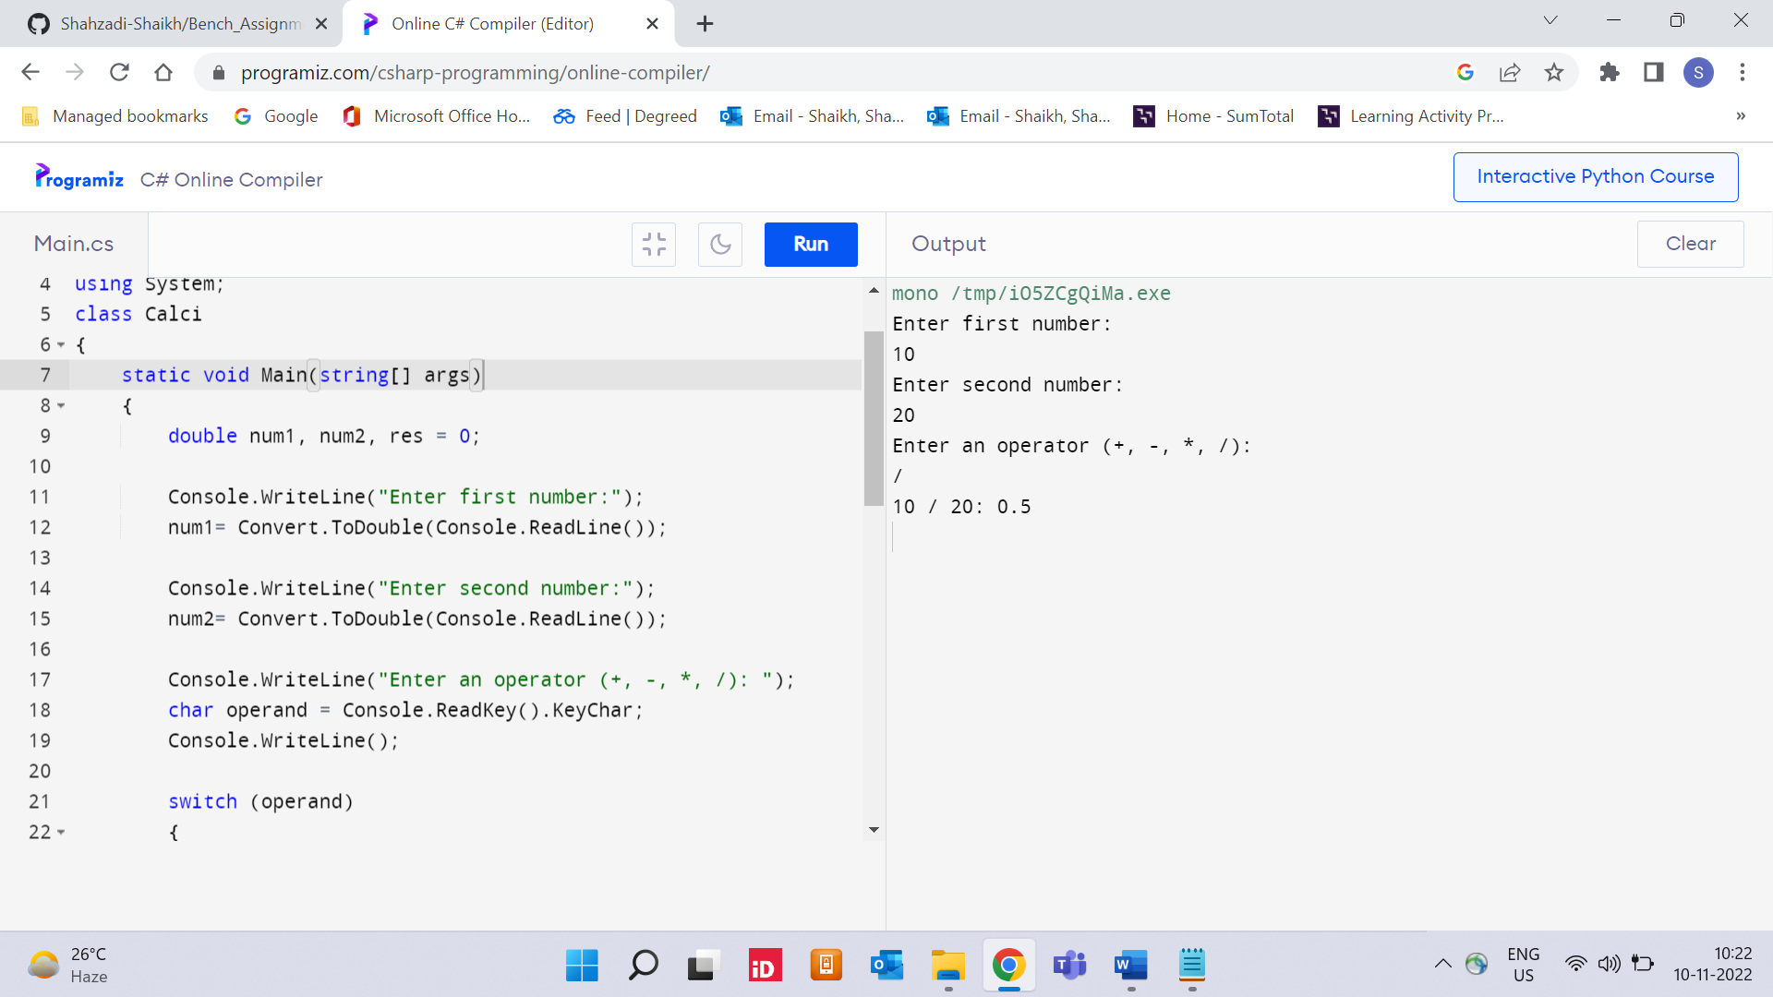

1. Accept average marks of five students. Display the highest marks obtained.

**Output**

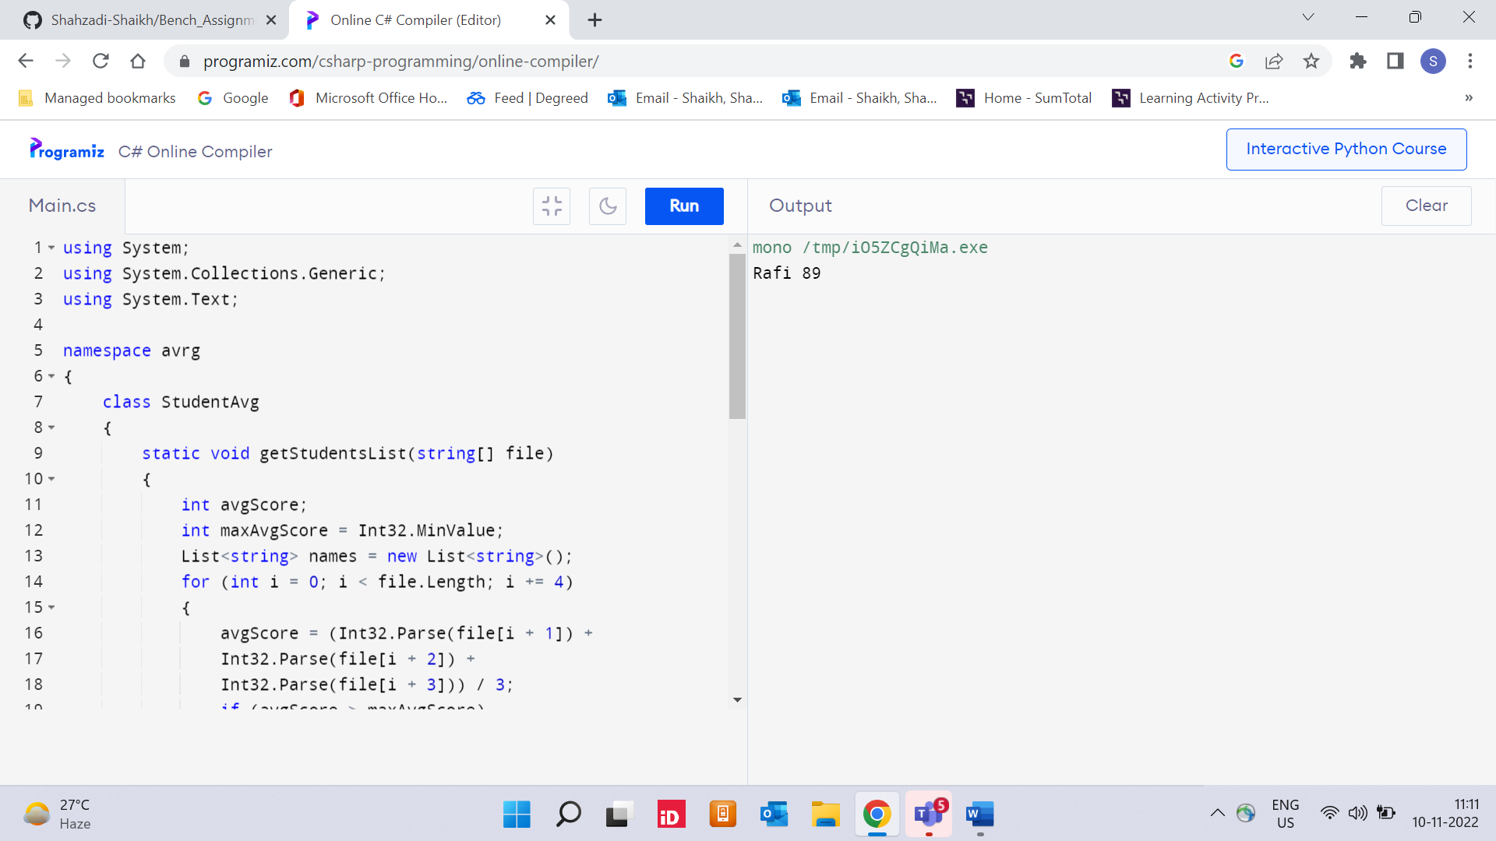

1. Write a static method to accept param array of integers. The method should find the sum of all the integers passed and display the result. Write a client program to call the method.

**Output**

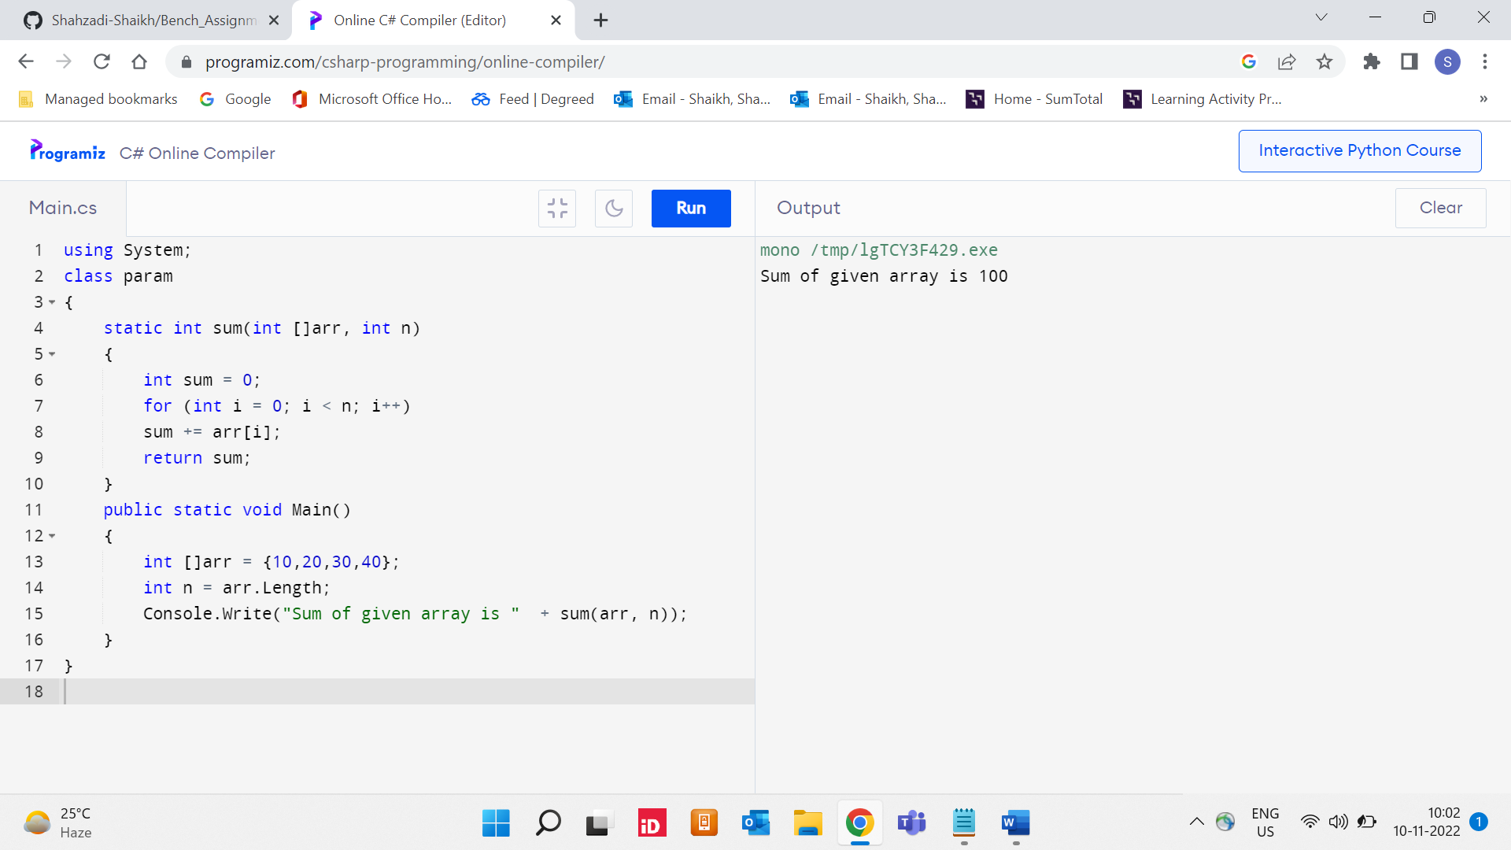

1. Write a method to swap two integers. The client code should call the method and print the swapped value.

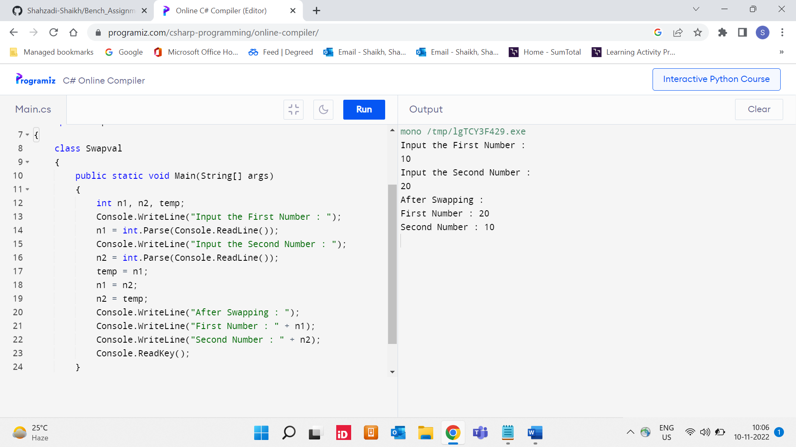

1. Write a single method that calculates the area and circumference of the circle. The area and circumference should be displayed through the client code

**Output**

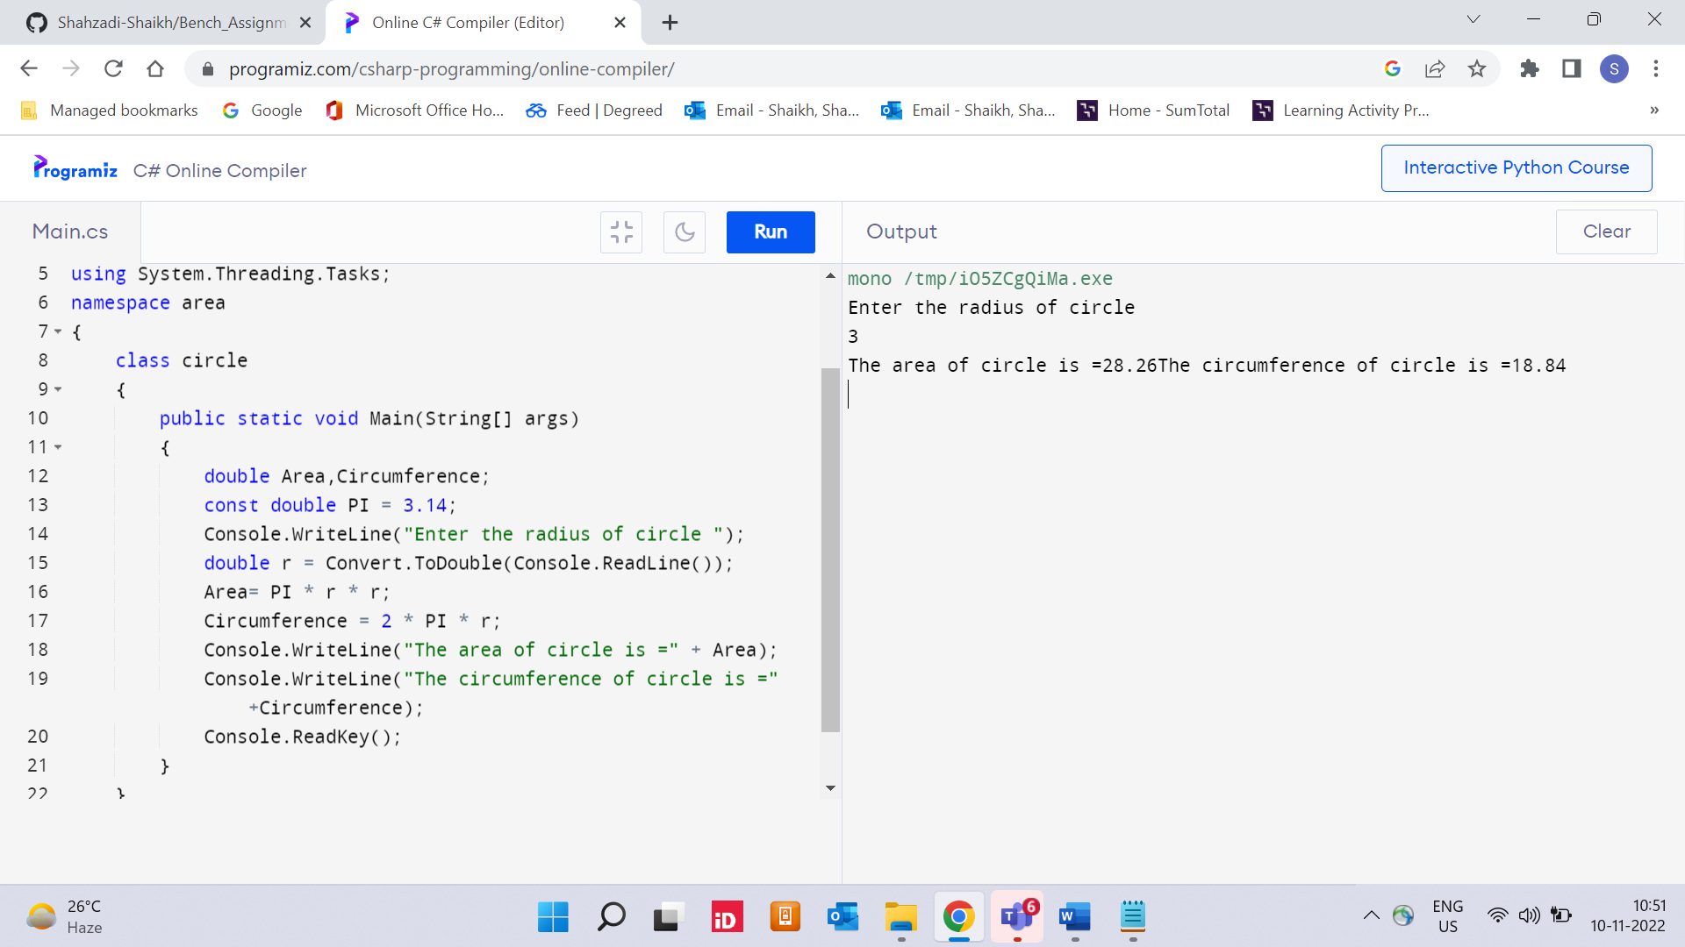

1. Create a structure Book which contains the following members:

bookId, title, price, bookType

Type of the book should an enumerated data type with values as Magazine, Novel, ReferenceBook, Miscellaneous. Write a console based application to do the following tasks.

* 1. Accept the details of the book
  2. Display the details of the book. The type of book should be displayed as a string e.g.:

Magazine

Note: Use methods for accepting and displaying details.

**Output**

